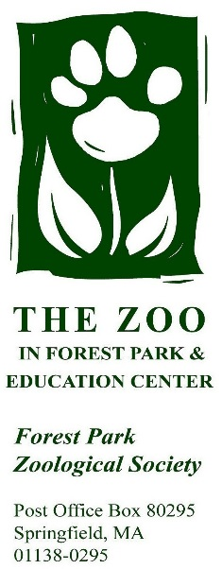
Charitable Bequest Intention Form (Confidential)
Please use this form to share your desire, barring any changes, to make a charitable bequest to the Forest Park Zoological Society (Federal tax ID #046145635).

This form is for informational purposes only. We pledge to hold this information in the strictest of confidence.

Donor Intent and Information:
As evidence of my desire to inspire our community to respect and value the natural world through education, conservation and rehabilitation, I wish to inform the Forest Park Zoological Society that you have been named in my estate plans.

______________________________ ______________________
NAME DATE OF BIRTH

As of this date, the approximate value of my/our gift is $___

If the gift is a percentage of the estate, please indicate the percentage. ____

My/our gift will be made through the following:

Beneficiary or Payable on Death (POD) Designations
☐Bank/investment accounts

☐Brokerage Account

☐Certificate of deposit (CD)

☐ Charitable Gift Annuity

☐Donor Advised Fund (DAF)

☐Life Insurance

☐Retirement plan assets
(e.g. IRA, 401(k), 403(b))

☐Savings account

Will
☐Beneficiary in a will

Trust
☐Beneficiary in a living trust

☐Charitable Remainder Trust

☐Charitable Lead Trust

I/We designate this gift to be used for:
☐ UNRESTRICTED support
Please direct this gift to the area of greatest need.

☐ RESTRICTED support (designate below):
☐_________________________
Gift Recognition:

☐ I/we give the Forest Park Zoological Society permission to list my/our name(s) as donor(s) of a legacy gift.
☐ I/we prefer that our gift be anonymous.
☐ I/we would like to share my/our story to inspire future planned gifts to the Forest Park Zoological Society

_________________________________________________________________
Full name as you would like it to appear for recognition (plaques, articles, etc.)

_______________________________ ______________
SIGNATURE DATE

________________________________________
PRINTED NAME

Please share this form with your legal representative, and return a copy to:
Sarah Tsitso
Executive Director
The Zoo in Forest Park & Education Center
P.O. Box 80295
Springfield, MA 01138

